**Technical Documentation – Deploy_WEB_Report_Artifacts_PMP**

1. Workflow – Stages (from SVN), Compiles and Deploys WEB Reports to an Environment.



1. Workflow Extra Vars

The PMP URL is defined at the workflow level

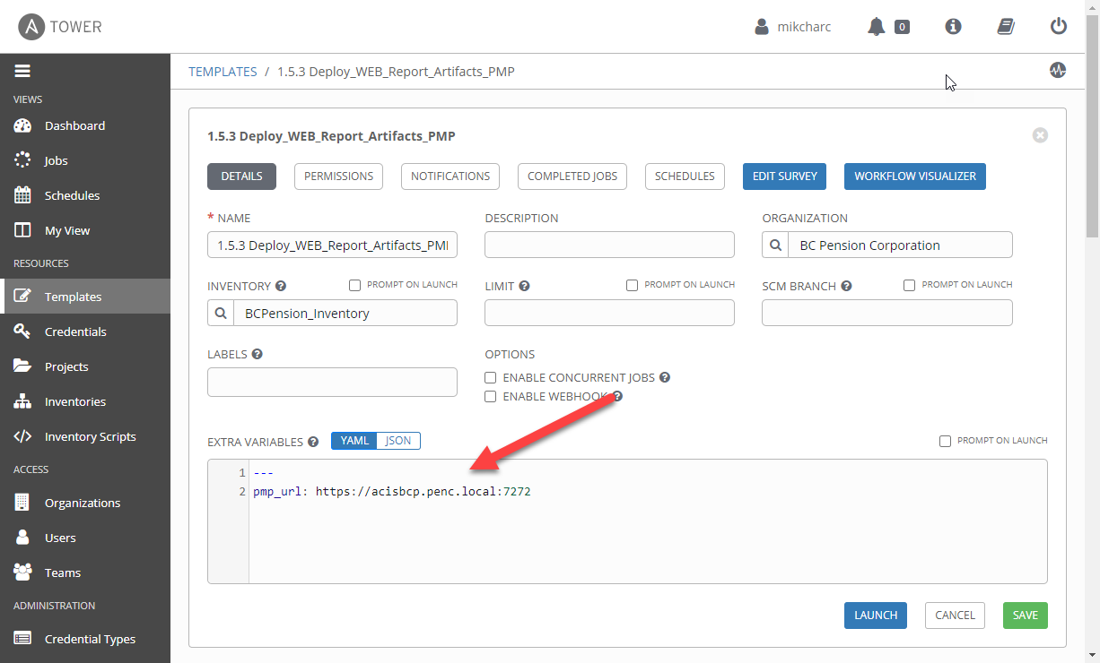

1. Survey – User Supplied Variables

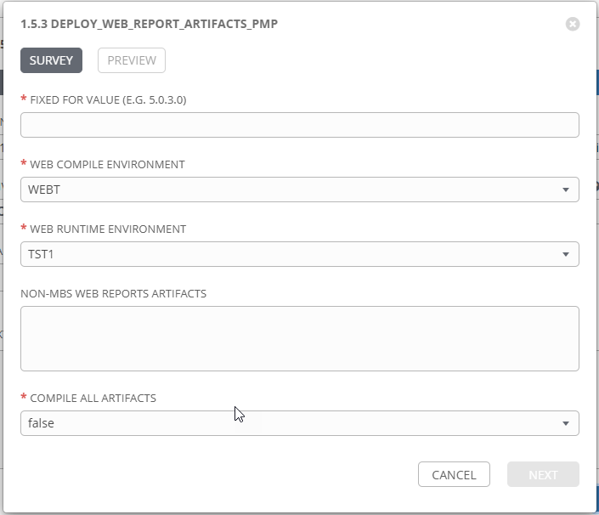

|  |  |  |  |
| --- | --- | --- | --- |
| **Survey Extra Variables** | **Prompt** | **Type** | **Description and Usage** |
| FFV | Fixed For Value | Text | The fixed for value for the deployment – must be for the format ###.###.###.### (i.e. 58.0.12.0). Numbers only with a maximum of 3 digits and there must be 4 sets separated with a ‘.’. Used to create staging and deployments directories. Used by all job templates in the workflow |
| WEBENV | Web Compile Environment | Multiple Choice Single Pick | The WEB Environments to Compile the WEB Report artifacts against: WEBD, WEBT, WEBM, WEBP. |
| ENV | WEB RUNTIME Environment | Multiple Choice Single Pick | The Environment to Deploy the WEB Report Artifact into: DEVL, DEV3, RDEV, TST1, TST2, TST3, MUAT. Only a single environment can be deployed to per workflow execution |
| WebArtifacts | Web Reports Artifacts | Text Area 20,000 characters | The SVN URL for each Report Artifact to be compiled and deployed. Each URL has to be on a separated line.  Note this variable is optional and if left blank the FAR Artifact(s) would have to have been staged by a previous execution. If the stage directory does not contain any artifacts the workflow will fail. |
| CompileAll | Compile All Artifacts | Multiple Choice Single Pick | True or false – default of false will only compile forms and reports that exist in the stage directory. If a pll is part of the deployment, CompileAll **MUST** be set to true, logic being all FAR Artifacts must be recompiled if a new pll is deployed (re: Geoff G.). |

1. Jobs Used by the workflow - http://owl.penc.local:18080/svn/deploy_automation/trunk/Ansible_PlayBooks/FAR

| **Job Template** | **Ansible Playbook** | **Credentials / host** | **Project** | **Description and Usage** |
| --- | --- | --- | --- | --- |
| create_web_compile_playbook_vars | create_web_compile_playbook_vars.yml | None – runs on localhost as awx linux user | FAR Deployments | DeploymentLogDir: /codemove_common/dp_automation/deployments/071.000/071.000.004.000/FAR  Runtime_Directory: /opt/ipas_app_test/tst2  StageDir: /codemove_common/dp_automation/stage/071.000/071.000.004.000/FAR  WEB_Compile_Directory: /export_home/codemove/compile/ipas12c/webt  WEB_DB: WEBT  Web_Deployment_Feedback: ' '  far_server: daulis1bcp  stage_server: diagoras1bcp  tower_hostname: pdeploy1bcp.penc.local |
| stage_web_artifacts | stage_web_artifacts.yml | Codemove for {{stage_server}} – diagoras1bcp  pendeploy_svn – used to extract artifacts using the svn urls supplied. | FAR Deployments | When the WebArtifacts is populated with SVN URLs export the artificats from SVN and place them in the Batch Staging directory {{StageDir}}/artifacts/Batch.  Creates a Staging file report in the {{DeploymentLogDir}} |
| check_web_staged_files | check_web_staged_files.yml | Codemove for {{stage_server}} – diagoras1bcp | FAR Deployments | Checks the {{StageDir}}/artifacts/Web to make sure at least one of *.rdf file(s) exists. If there are no artifacts in the directory or the directory does not exist produce an error. |
| copy_far_artifacts_to_web | copy_far_artifacts_to_web.yml | Codemove for {{far_server}} typically daulis1bcp | FAR Deployments | Copies all FAR Artificats staged into the {{WEB_Compile_Directory}}. If any *.olb or *.tif files exist copy them to the {{Runtime_Directory}} since they do NOT get processed by any of the compile playbooks. |
| compile_web_reports | compile_web_reports.yml  Calls  compile_single_web_report.yml | Codemove for {{far_server}} typically daulis1bcp | FAR Deployments | compile_web_reports, compiles WEB rdf files.  Obtains the SPLUSER Resource and Accound IDs from password managerpro using the {{ans_auth_token}} by passing in IPASUSER and {{WEB_DB}}_SPLUSER to the getResourceAccountDetails API.  Obtains the password from Password Manager Pro by passing the RESOURCEID and ACCOUNTID to the getResourceAccountDetails API.  Checks the password against the {{WEB_DB}} using sqlplus.  When CompileAll is true compile_single_web_report.yml is executed against ALL rdf files in the {{WEB_Compile_Directory}}. If CompileAll is false, compile_single_web_report.yml is executed only against rdf files in the {{StageDir}}/artifacts/Web.  If any of the rdf compiles produces an error {{Web_Report_Errors}} is populated.  {{Web_Report_Deployment_Feedback}} is populated for each rep created. |
| consolidate_compile_errors | consolidate_compile_errors.yml | None – runs on localhost as awx linux user | FAR Deployments | Consolidates all ERRORS generated – Note that this jobs is used by all Forms and Reports workflows (Online, Batch, web, etc.). |
| populate_web_deployment_logs | populate_web_deployment_logs.yml | Codemove for {{stage_server}} – diagoras1bcp | FAR Deployments | Populates the deployment log {{DeploymentLogDir}}/{{WEBENV}}_{{ENV}}_Web_Log.html with the rdf feedback generated during the compiles.  Populates the error log {{DeploymentLogDir}}/{{WEBENV}}_{{ENV}}_Web_Compile_Errors.html with any ERRORS generated during the compiles.  If Compile errors exist emails the {{DeploymentLogDir}}/{{WEBENV}}_{{ENV}}_Web_Compile_Errors.html file to:  - PENC_ITS_ADM_Release_Management@Victoria1.gov.bc.ca  - PENC_ITS_TSS_Midtier@Victoria1.gov.bc.ca |